Company Database Schema
- Create Database using wizard with the following schema then
Create DB Diagram and insert at least 2 rows per table
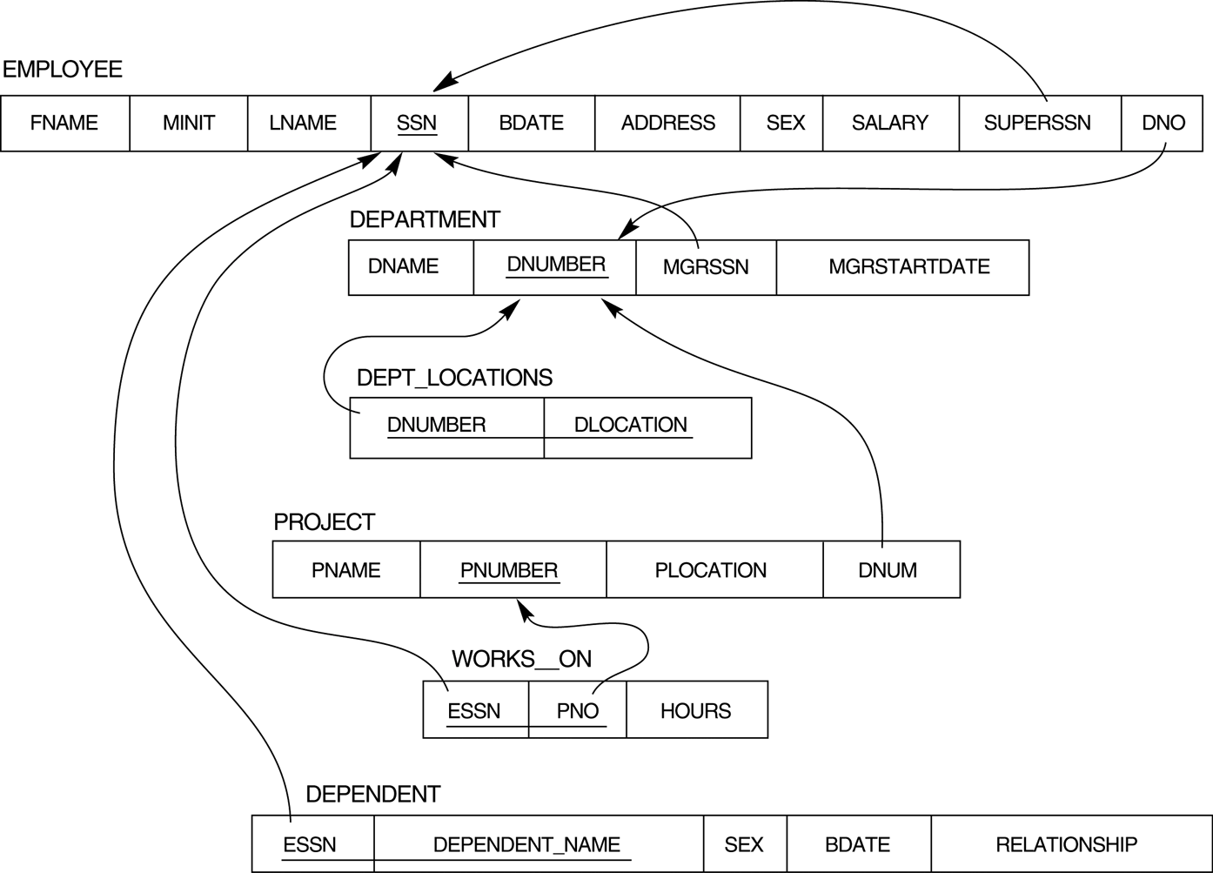

- Restore Company DB then
Try to create the following Queries:

- Display all the employees Data.
- Display the employee First name, last name, Salary and Department number.
- Display all the projects names, locations and the department which is responsible about it.
- Display the employees Id, name who earns more than 1000 LE monthly.

